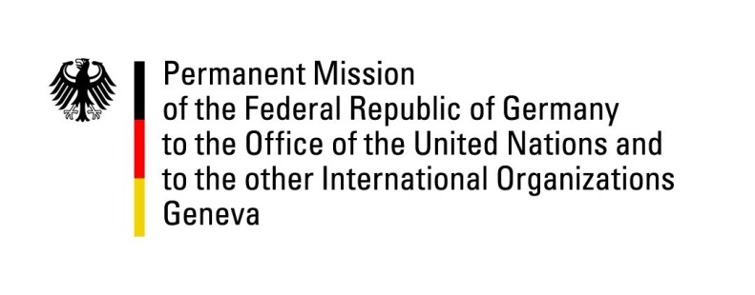

**United Nations Human Rights Council**

**25th Session of the UPR Working Group**

**Geneva, 2 May 2016**

**---**

**German national statement**

**Saint Vincent and the Grenadines**

Mr. President,

Germany warmly welcomes the delegation of Saint Vincent and the Grenadines to the UPR and commends the country for its achievements in the promotion and protection of human rights since the last UPR, in particular with regard to the strengthening of women’s and children’s rights - the Domestic Violence Act of 2015 being a critical step forward. We would like to encourage the Government of Saint Vincent and the Grenadines to invest further in these two important fields. Germany therefore offers the following recommendations for consideration:

1. Prohibit all corporal punishment of children, including at home, at schools, and as a sentence of the courts and work towards a popular understanding that corporal punishment of children is not beneficial but rather detrimental to the development of young citizens.
2. Adopt, without delay, new legislation that fully incorporates the principle of equality of women and men as well as a definition and prohibition of discrimination on the basis of sex and gender in the public and private spheres.
3. Reinforce measures to combat violence against women, including legislative amendments to the Criminal Code and the Domestic Violence Act and awareness raising campaigns in the public.